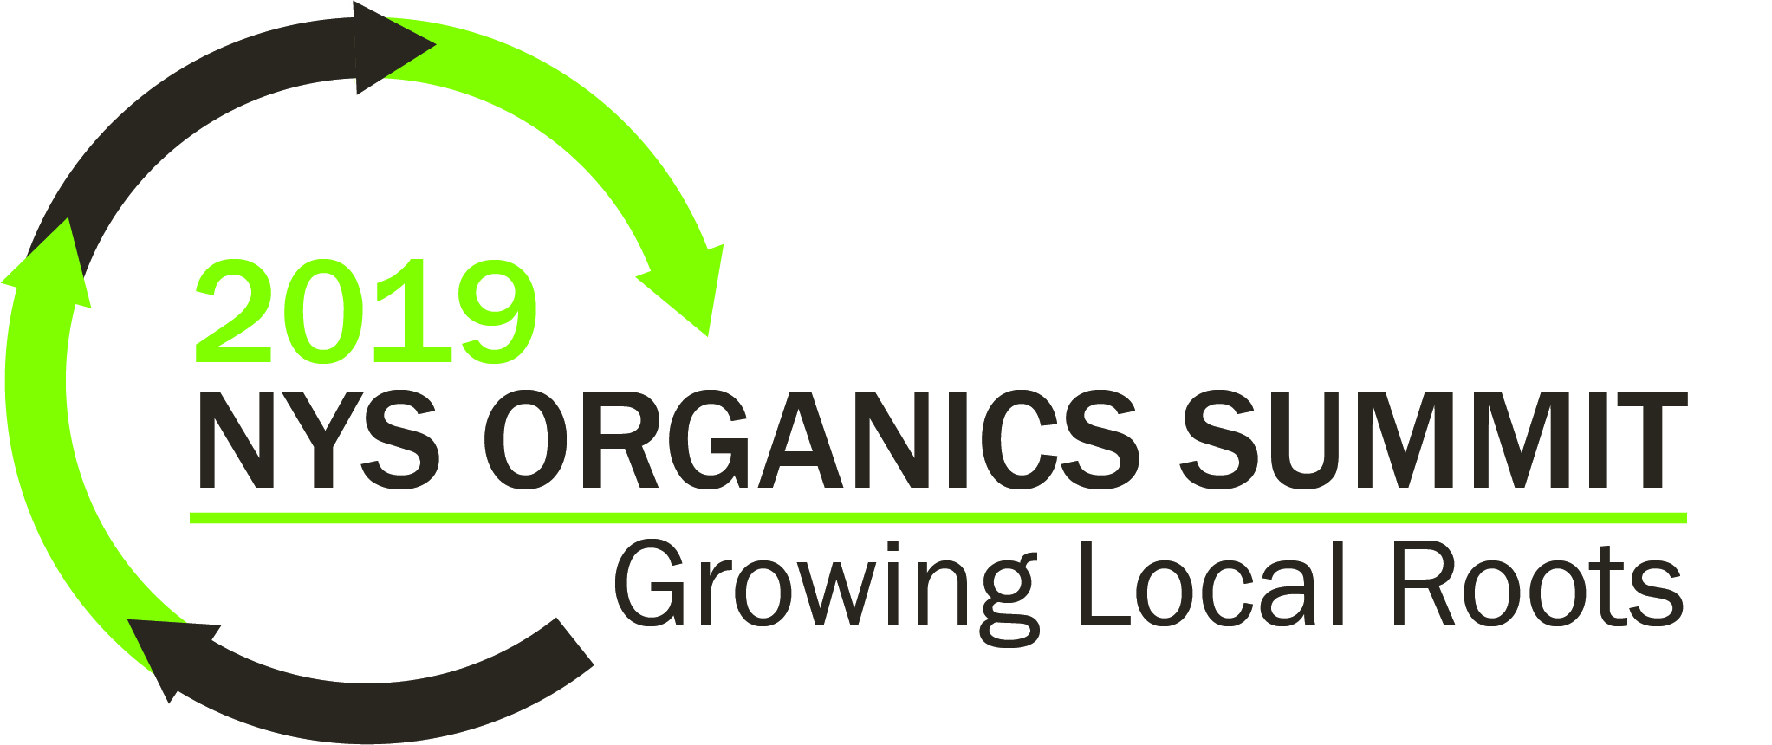
Contact nysar3@gmail.com with invoice/purchase order requests.

First Name: Last Name:
____________________________________________________________________________________
Title:
____________________________________________________________________________________
Organization:
____________________________________________________________________________________
Address:
____________________________________________________________________________________
City: State: Zip:
____________________________________________________________________________________
Phone: Email:
____________________________________________________________________________________

Registration Fees
☐ NYSAR³, NYSASWM, or SWANA-NY Member, Day 1 & 2 ($100.00)
☐ NYSAR³, NYSASWM, or SWANA-NY Member, Day 1 ONLY ($80.00)
☐ NYSAR³, NYSASWM, or SWANA-NY Member, Day 2 ONLY ($40.00)
☐ Non-Member, Day 1 & 2 ($140.00)
☐ Non-Member, Day 1 ONLY ($120.00)
☐ Non-Member, Day 2 ONLY ($80.00)
Additional Registration Items
☐ NYSAR³, NYSASWM, or SWANA-NY Member, Day 2 Add-On Package (Lunch & Tour) ($20.00)
☐ Non-Member, Day 2 Add-On Package (Lunch & Tour) ($35.00)

Dietary Preference
Make check payable to: NYSAR³
Email registration form to: nysar3@gmail.com
Mail check and completed form to:
NYSAR³, 1971 Western Avenue #1180, Albany, NY 12203
☐ Vegetarian
☐ Vegan
☐ Gluten-Free
☐ Lactose Intolerant

