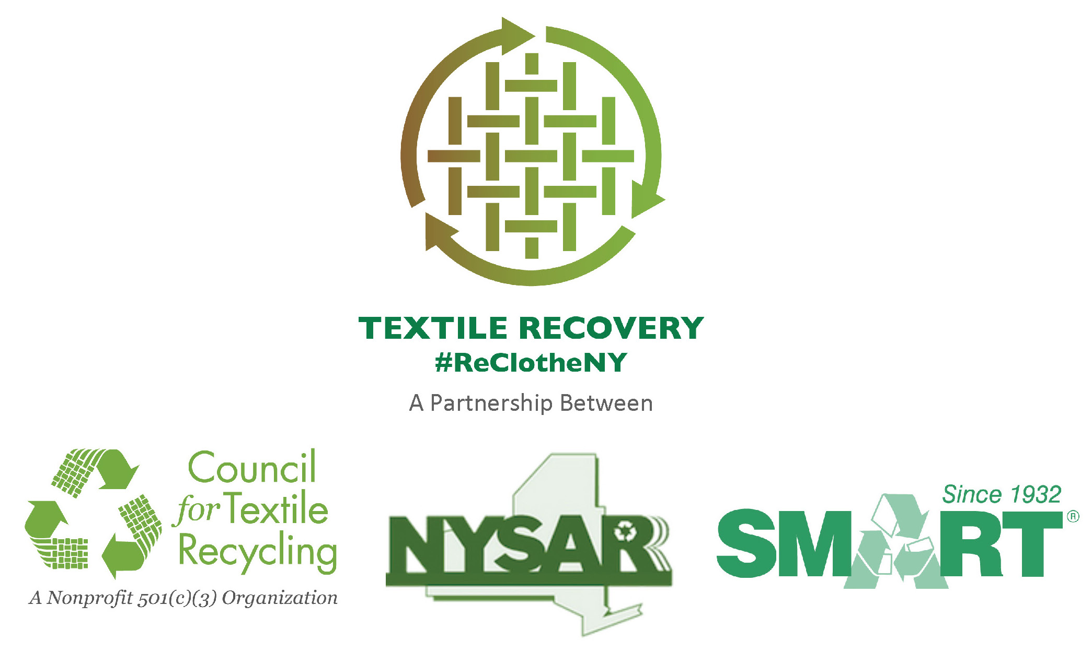
10/21/14

NOT-FOR-PROFIT AND CHARITABLE ORGANIZATIONS
PARTNER WITH PRIVATE SECTOR COMPANIES
TO MANAGE DONATED CLOTHING AND TEXTILES

The New York State Association of Reduction, Reuse, and Recycling (NYSAR3), the Secondary Materials and Recycled Textiles Association (SMART), and the Council for Textile Recycling (CTR) are launching a state-wide campaign to “Re-Clothe NY” on clothing and textile recycling. On average, Americans place 70-pounds of used clothing and other textile products into the trash. Of these items, NYSAR³, SMART, and CTR say an estimated 95% could have been reused or recycled.

Major charitable organizations typically sell about 20% to 30% of the clothing donations they receive in their retail outlets. Smaller local charities often sell a higher percentage locally, but both major and local charities have clothing and textiles they cannot sell. That’s when these charitable and not-for-profit organizations partner with the for-profit used clothing industry. For-profit recyclers purchase, in bulk, the clothing and textiles charities are unable to sell; providing an additional revenue stream that supports the charity’s mission.

Eventually, the for-profit companies will sort the items and guide them to the appropriate reuse/recycling stream. SMART estimates approximately 40% of the items will be reused for their original purpose. Often the company ships used clothing to markets in Africa, Europe, Central and South America and Asia. Approximately 30% of the textiles will be cut into industrial wiping and polishing cloths, and 25% will be shipped to mills where the textiles are reduced to fiber. The newly reclaimed fiber is then used to manufacture new products such as home insulation, carpet padding, car sound-proofing and stuffing for pet beds, etc.

NYSAR³, SMART, and CTR want all New York residents to remember to “Re-Clothe NY” and recycle their clothing and textiles. DON’T throw them away.

