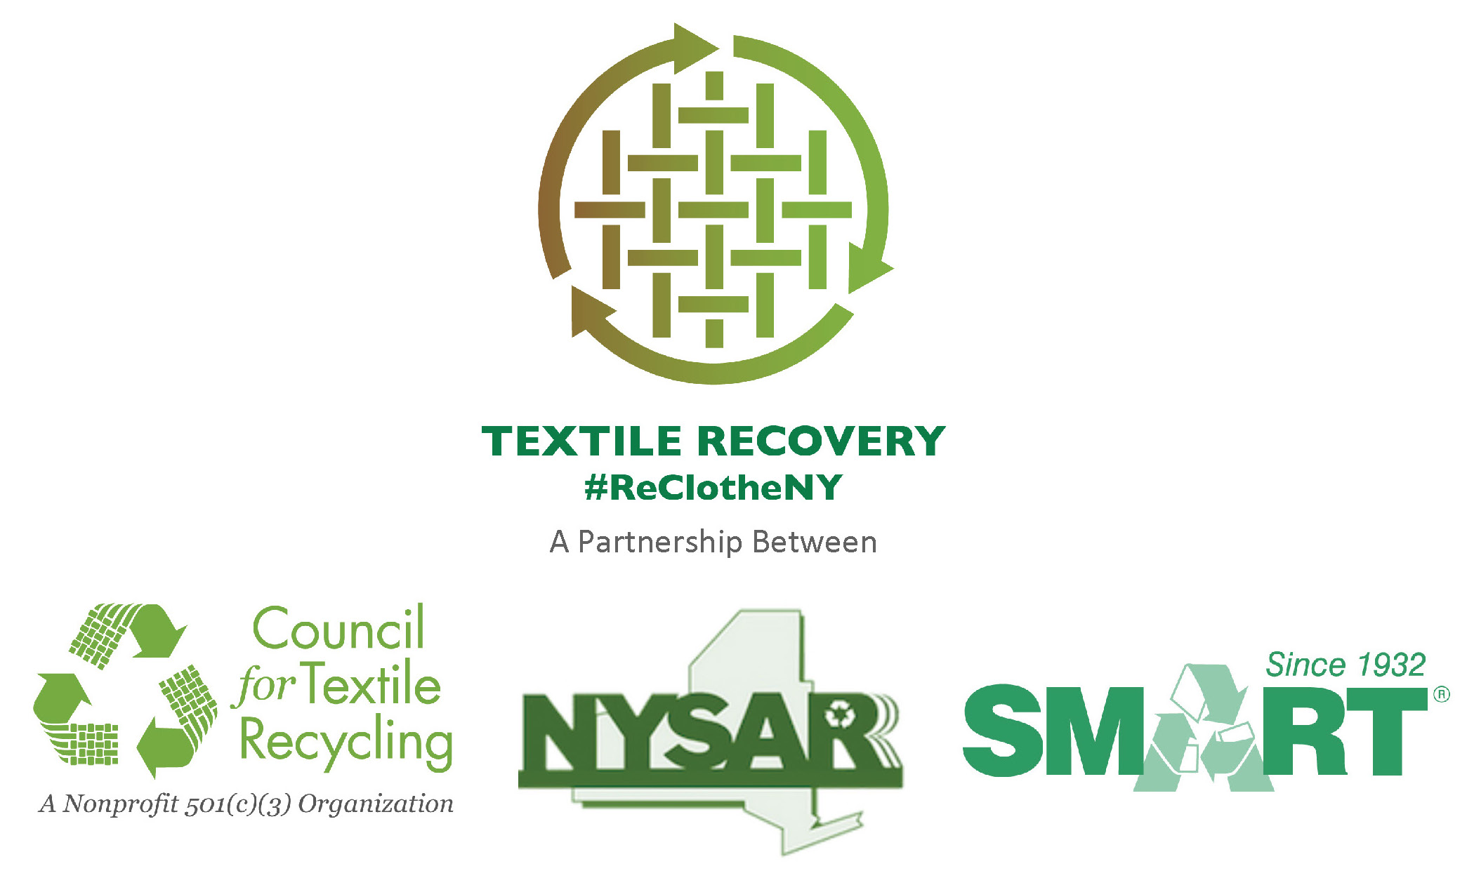
FACT SHEET

- Each year in New York State, over 1.4 billion pounds of clothes and textiles are trashed, with an estimated market value of over $200 million.
- Over 9,600 jobs across the state would be created if this material was recovered for reuse and recycling.

- NYSAR3, SMART and the Council for Textile Recycling estimates 95% of all used clothing, footwear and other cloth household products such as sheets, towels, curtains, and pillowcases can be recycled.
- 85% of unwanted clothing, footwear, and household textiles is winding up in landfills; while only 15% is being reused or recycled.

- The EPA reports 2.25 million tons of used clothing and household textiles are recycled annually, while more than 12 million tons (12.08) are discarded in our nation’s landfills and incinerators.
- Recycling 2 million tons of clothing per year is the equivalent of removing 1 million cars from the nation’s roads.
Nationwide Greenhouse Reduction Impact of Other Recyclables:
- Yard waste equals removing 170,000 cars
- Glass equals removing 210,000 cars
- Plastic equals removing 640,000 cars
- Recycling aluminum equals removing 1.3 million cars.
- The EPA’s report on municipal solid waste (2102) states 5.7% of all of the materials going into landfills or waste-to-energy facilities (waste combustors) is clothing or textile products.

- 40% of used clothing is re-used for its original purpose
30%t of recycled clothing /textiles is cut into industrial wiping and polishing cloths
25% is reduced to fiber
The remaining 5-percent is thrown away because it is wet (mildewed) or had been stained with a solvent such as gasoline.
SOURCE: U.S. Environmental Protection Agency report: Municipal Solid Waste Generation, Recycling, and Disposal in the United States: Facts and Figures for 2012.

