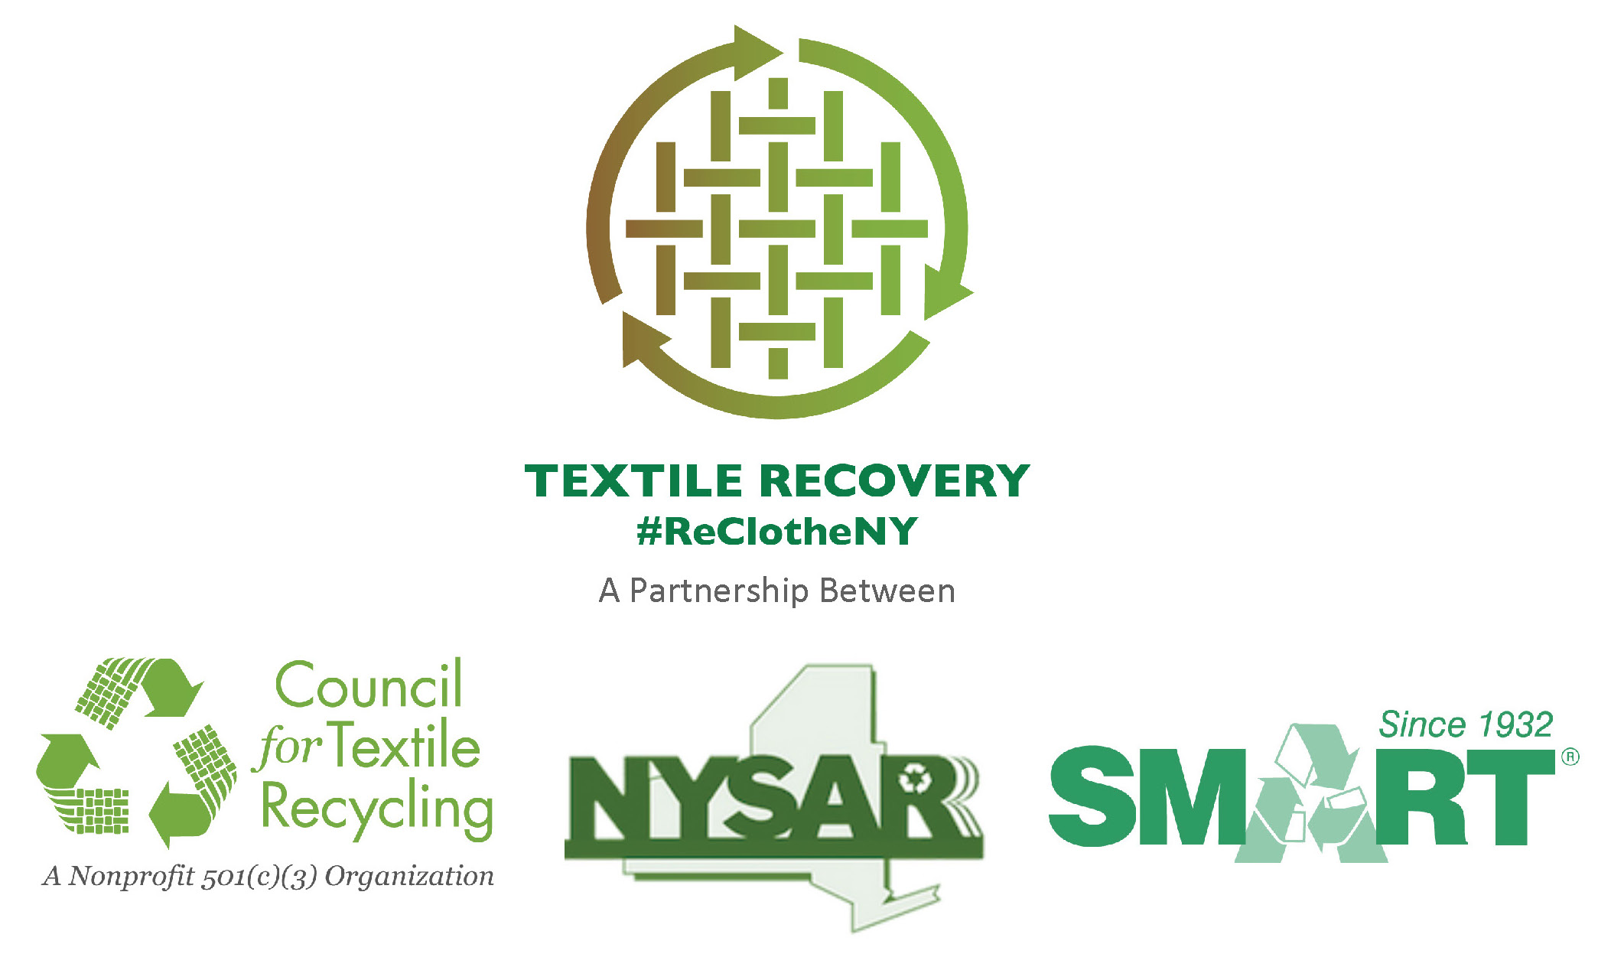

Contact: David Lupinski
email: davel@ohswa.org
phone: 315‐733‐1224 ext. 1600

LETTER TO THE EDITOR
November, 2014
As America Recycles Day Nears on November 15,
National and State Recycling Leaders Challenge New York State Residents to
Keep 1.4 Billion Pounds of Clothing and Textiles Out of the Trash

Submitted by David Lupinski,
President, New York State Association for Reduction, Reuse, and Recycling (NYSAR³)
Since the first Earth Day 44 years ago, remarkable progress has been achieved in protecting our environment and conserving natural resources. From a recycling standpoint, each of us doing our small part every day to keep bottles, cans, and paper materials out of the trash is collectively reducing greenhouse gases, diverting materials from limited landfill space, and supporting thousands of jobs statewide.

Unfortunately, the same environmental achievement cannot be claimed when it comes to unwanted clothing and other household textiles. New York State residents trash about 1.4 billion pounds of these materials each year, with a market value exceeding $200 million. That’s approximately 70 pounds for every New York citizen annually, and an economic loss of $1 billion over the course of only five years! If all of us kept unwanted clothing and textiles out of the trash, approximately 9,000 new jobs could be generated across the state to manage this material stream.

In conjunction with “America Recycles Day” on Saturday, November 15th, communities across the state are teaming up to encourage residents to donate and recycle their unwanted clothing and other household textiles. The “Re-Clothe NY” campaign is lead by the New York State Association for Reduction, Reuse, and Recycling (NYSAR3), in conjunction with the Secondary Materials and Recycled Textiles Association (SMART), and the Council for Textile Recycling (CTR). Information about what to donate, and where to donate, can be found at www.NYtextiles.org

A few facts:

- 95% of all used clothing, footwear and other cloth household products, including sheets, towels, curtains, blankets, and pillowcases can be recycled, including clothing that is torn, missing buttons, or has broken zippers or a few stains.
- Currently, 85% of unwanted clothing, footwear, and household textiles are winding up in the trash; only 15% is being reused or recycled.

- The US EPA reports that more than 12 million tons of used clothing and household textiles are discarded across the U.S. annually, while only 2.25 million tons are recovered for reuse or recycling.
NYSAR³ has formed a coalition of non-profit charitable organizations, including the Rescue Mission, Salvation Army, and Goodwill Industries, and for-profit used clothing companies, to collaborate in helping NY residents to keep textiles out of the trash. Recovering these materials will produce environmental, economic and social benefits across New York State.

On the first Earth Day 44 years ago, as a nation, we took notice of how we were destroying our environment. Collectively, we decided to take action and make a difference. In recognition of America Recycles Day on November 15, NYSAR³ challenges all New York residents to once again make a difference by dropping off their unwanted clothing and textiles to reduce waste, generate jobs, and preserve natural resources.

David Lupinski
President, NY State Association for Reduction, Reuse, and Recycling

