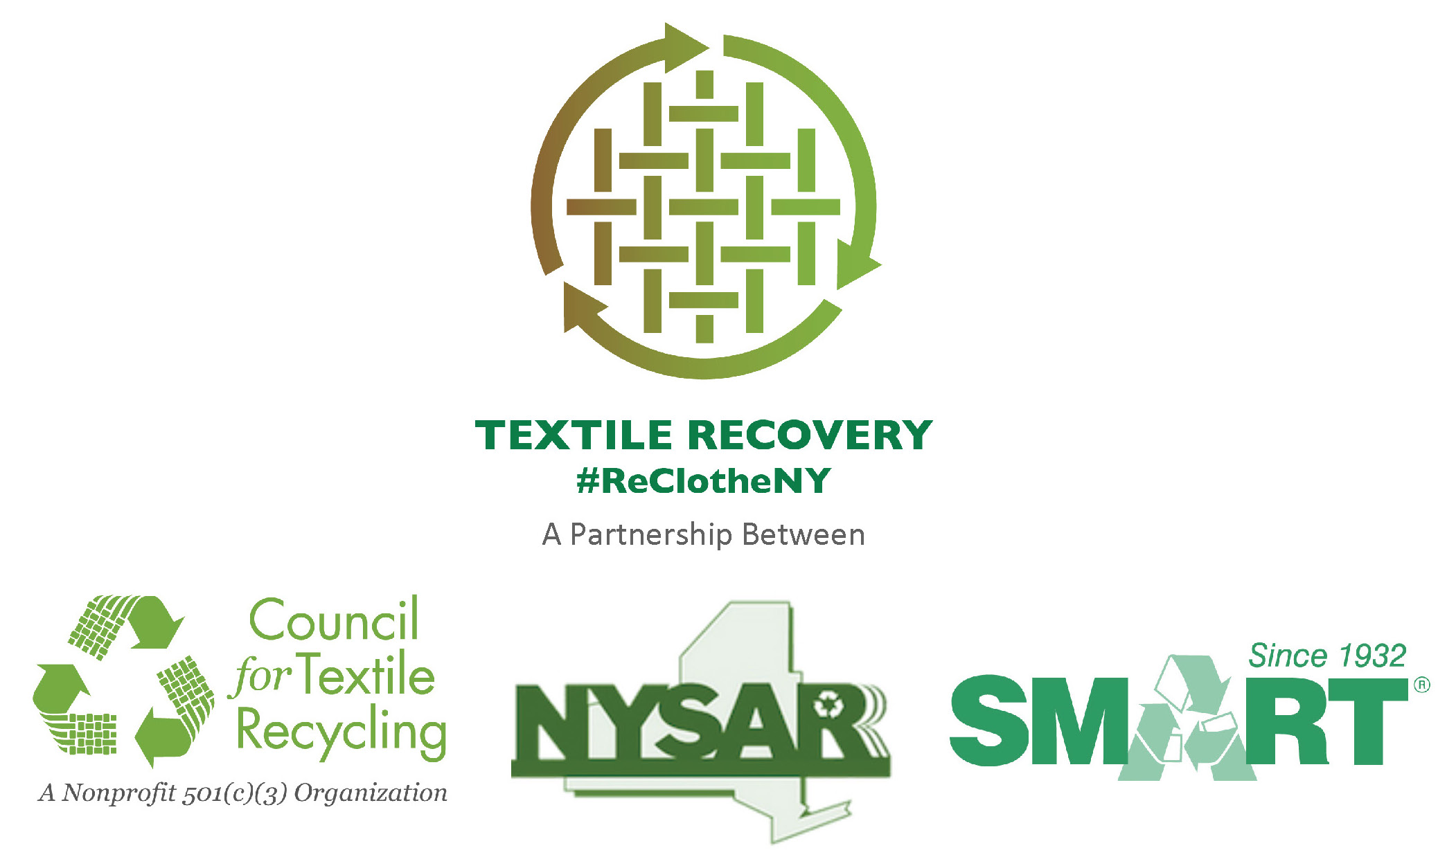

MEDIA ADVISORY
CONTACT: Name
Title
Municipality/Department
XXX-XXX-XXXX (office)
XXX-XXX-XXXX (cell)
Email:________________

(insert name of municipality or department) to (Host or Announces) “Re-Clothe NY” Textile Recycling (Event or Program)

NYSAR³, a statewide professional recycling association, estimates
more than 1.4 billion pounds of clothing and textiles
– with a market value exceeding $200 million --are trashed annually
in New York State; 95% of which could have been recycled.

Locally about (insert .05 x total MSW) tons of textiles are estimated to be trashed annually

As part of a statewide environmental campaign to encourage New York State residents to recycle unwanted clothing, footwear and other textile products, the ___________Department of ________ is (insert description of your community’s special textile collection efforts, such as: hosting a “Re-Clothe NY” recycling collection and educational event. Collection receptacles will be available for recycling drop off).

_________ will be available for interviews to describe details of the (event/new program). The effort is aimed at increasing the recovery of clothes and textiles in our community; across the U.S., only 15% of these materials are recovered for reuse and recycling, while 85% is trashed.

WHO: insert name of municipality, Insert name of department or agency
WHAT: “Re-Clothe NY” Clothing, Footwear and Textile Recycling Event
Acceptable Items:
- Old Clothes – all items should be clean and dry;
rips, stains, missing buttons, non-functioning zippers are okay;
- All footwear;
- Accessories: hats, gloves, scarves, pocketbooks, duffle bags, totes, belts, ties;
- Linens: sheets, blankets, comforters, dishtowels, throw rugs, draperies, table linens, placemats;
- Stuffed animals.

WHEN: insert Date and Time

WHERE: insert Address
ADDITIONAL DETAILS:

ONLINE INFORMATION: website: www.NYTextiles.org
Facebook: https://www.facebook.com/NYSTextileRecovery
Twitter: #ReClotheNY



#####

