10/21/14

PLACEMENT TIPSHEET

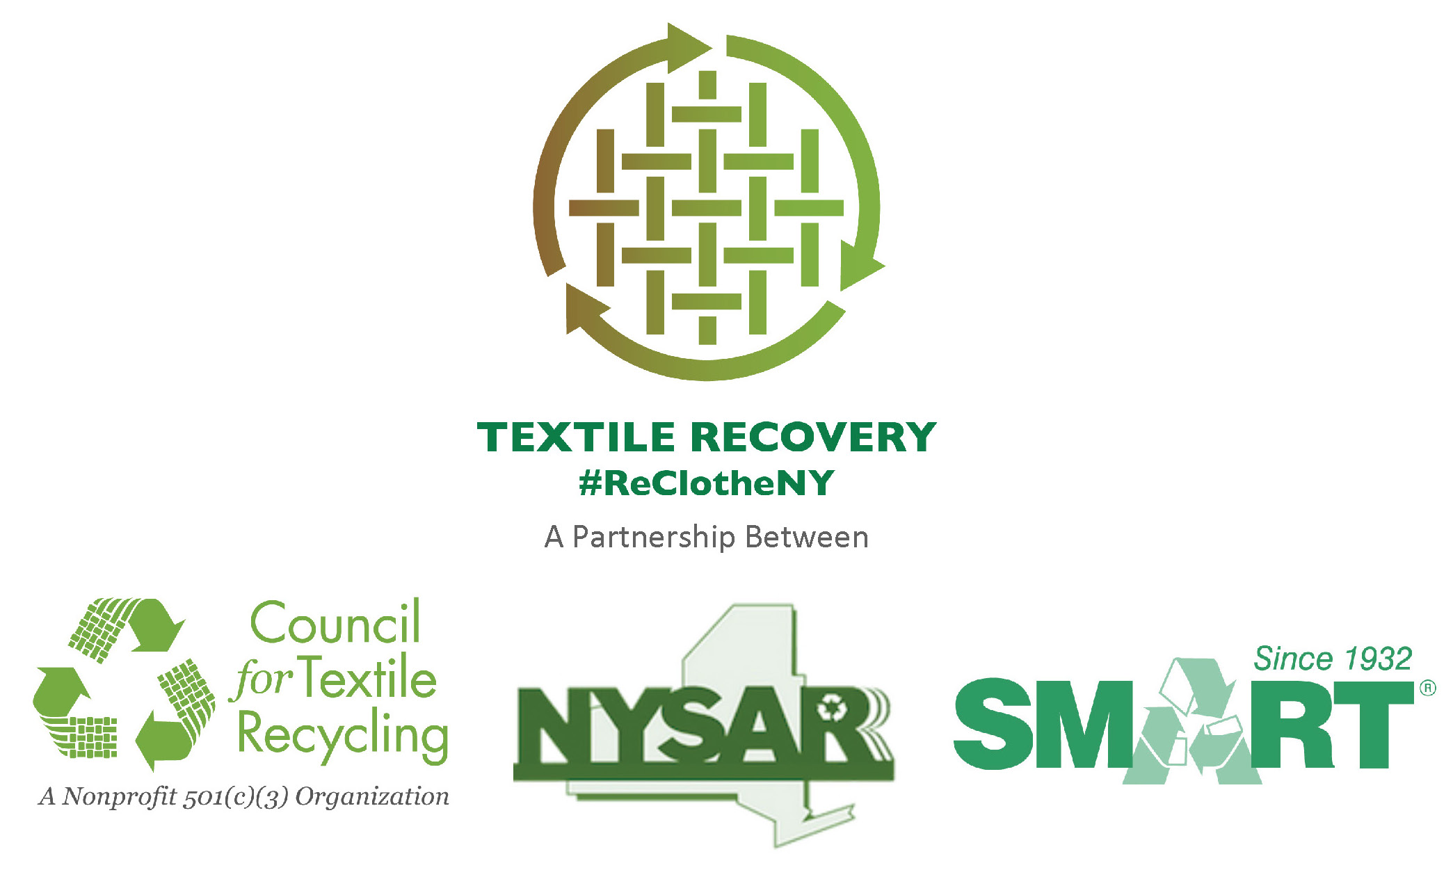
How to get local media outlets to cover
your clothing and textile recycling event.

- First contact with television newsroom assignment desk, newspaper metro desk, and radio station news room should be approximately 10 days in advance of your textile recycling event.
- Submit Media Alert with event details via email
- Follow-up email with phone call to assignment desk the following day
- Confirm email was received and event is on the newsroom’s calendar of upcoming stories
- If email cannot be found (a likely response) get the person’s name you are speaking with and re-submit the Media Alert via email to that person’s attention.
- Contact newsroom approximately 3-days prior to event by phone.
- Confirm event is still on the story calendar
- Re-send Media Alert as needed
NOTE: Most newsroom executives make the final decision to cover an event on the morning of the event (for mid-later day events. Decisions on morning events are made the day before the event.)
- Activity at an event is more likely to attract television, radio and print reporters.
Think like a television reporter while creating your event:
- Television reporters (and videographers) use images as much as words when developing a news story. Be sure your event includes activities and/or items that can be filmed such as: collection bins for recycling, trucks, moving forklifts, posters. Newspaper reporters (photographers also use images, including video when telling their stories.)
- Describe the activities with the most “visual” appeal when speaking with the editor about your event.
- Create events that coordinate with other institutions/activities
- Coordinate event with school PTA as a recycling education event
- Host event at local solid waste facility to promote diversion of clothing and textiles from landfills and incinerators.
- Bring together non-profit organizations and for-profit companies that both process clothing and textiles to present a “united” message on how to keep clothing and textiles out of the waste stream

- Identify one individual to be the media coordinator for the event.
- Provide that person’s cell phone number to all media representatives who indicate they may be covering the event.
- The media coordinator does not need to be the spokesperson for the event. Rather, they should:
  - Greet reporters as they arrive at the event
  - Coordinate interviews with the spokesperson for the event
  - Point out activities the photographer/videographer/reporter will want to film and/or photograph.
- Immediately following the event, use the news release template to submit information on the event to all media outlets that were unable to send a reporter to the event.
- Include 1-to-3 photos with the news release.
- Don’t forget to contact online media outlets such as Patch.com
- Return all phone calls from a reporter/newsroom promptly
- Make covering your event as easy as possible for the media outlet/reporter.

- Remember, breaking news may pull coverage away from your event. Don’t be disappointed if reporters do not attend; use follow-up news release template to get post-event coverage in newspapers, on television and radio station web sites.

