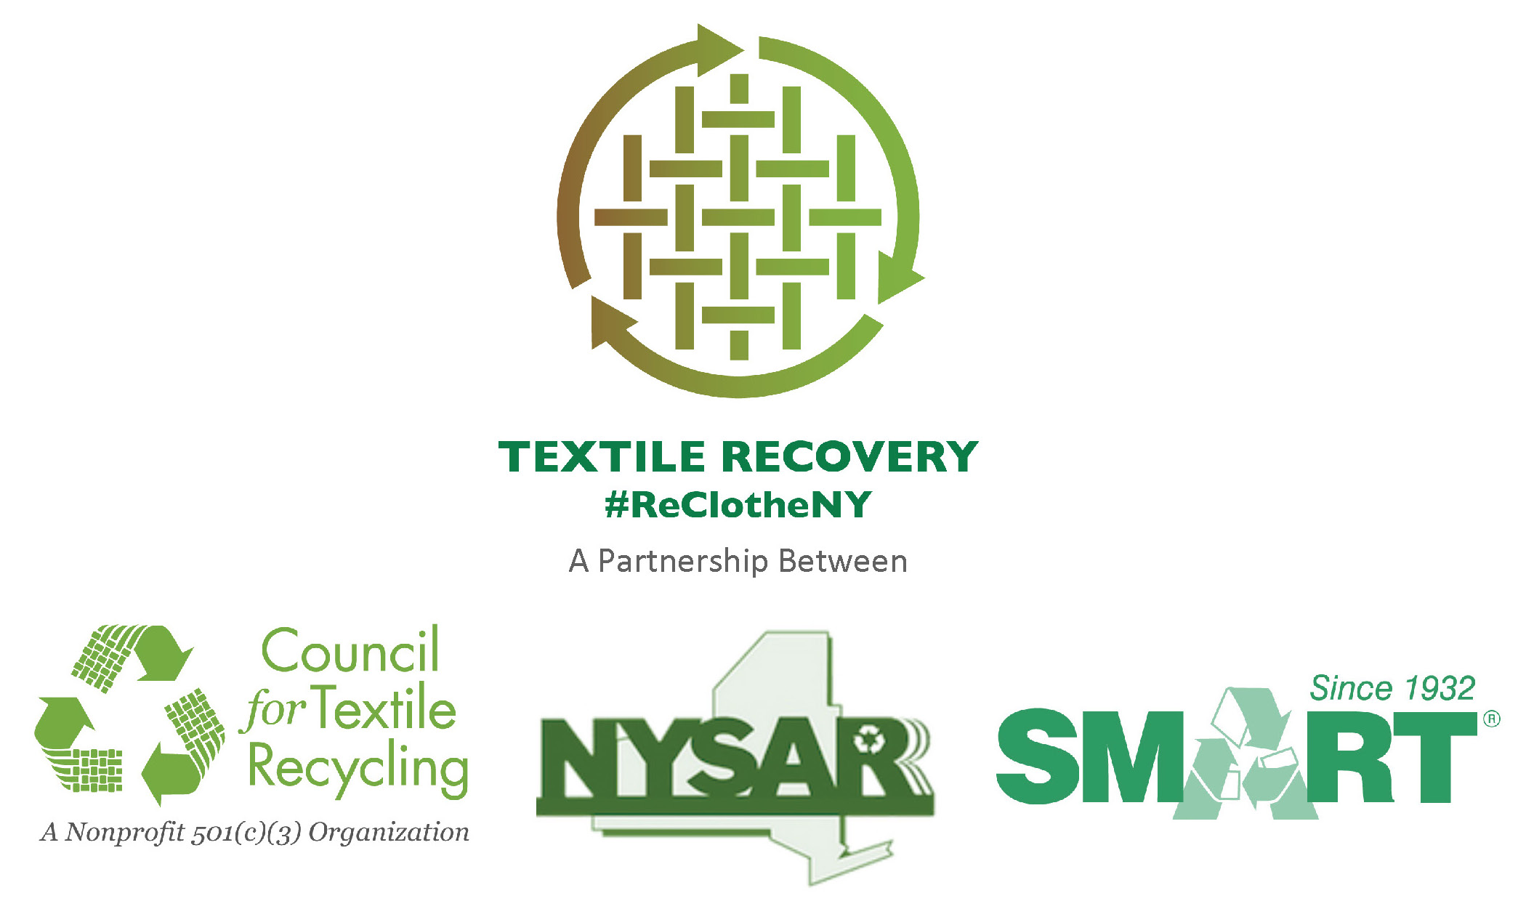
10/21/14

NEWS RELEASE

FOR IMMEDIATE RELEASE

CONTACT: Name , Title
Municipality/Department
XXX-XXX-XXXX (office)
XXX-XXX-XXXX (cell)
Email: Name Protocol@Domain Name.XXX

NYSAR³ Launches “Re-Clothe NY” Textile Recycling Campaign
NY State Residents Trash an Estimated 1.4 Billion Pounds
of Recoverable Clothes and Textiles Annually,
with a Market Value of Over $200 million
Over 9,000 Jobs Could be Created Statewide
Through Increased Textile Recovery

Albany, NY (November 15, 2014; America Recycles Day!) – The New York State Association of Reduction, Reuse, and Recycling (NYSAR³), in conjunction with the Secondary Materials and Recycled Textiles Association (SMART), and the Council for Textile Recycling (CTR) today announce the kick-off of a state-wide campaign to “Re-clothe NY” on clothing and textile recycling. Throughout the state, municipalities are initiating an outreach campaign that encourages New York State residents to “Re-Clothe NY” by recycling their unwanted clothing and household textiles, and not put them into the trash. Guidance to help residents recycle clothing and textiles is available at www.NYTextiles.org

According to NYSAR³, each year, New York State residents dispose of some 1.4 billion pounds of recoverable clothes and textiles, with an estimated market value over $200 million. NYSAR³ estimates that some 9,600 jobs would be created across the state if that material was dropped off for reuse and recycling. Across the country, only 15% of recyclable clothes and textiles are actually recovered; 85% ends up in the trash.

“Used clothing and other textiles such as sheets, towels, curtains, and pillowcases are extremely recyclable,” says David Lupinski, President of NYSAR³. “As part of this statewide campaign, communities across New York are launching special events and programs to urge residents to stop putting clothing and other textiles into the waste stream – even if it’s ripped, missing buttons, has a broken zipper, or is slightly stained -- and start sending all unwanted clothing and other textiles into the reuse/recycling stream; whether by dropping them off at a charitable organization, or by using clothing collection bins—they should NOT be placed in curbside recycling containers. Both non-profit charities and for-profit recyclers often work in conjunction to keep this valuable resource out of the waste stream.” Lupinski added that “More recycling means more jobs. In this case, we could create over 9,000 new jobs across the state in the not-for-profit and private sectors through the recovery of clothing and textiles that are currently trashed. To find textile drop off locations, residents should visit www.NYTextiles.org, or check with their local solid waste authority. ”

SMART estimates the average person throws away 70-pounds of used clothing annually; of those 70-pounds, 95% could have been reused or recycled. Industry officials say only clothing that is wet (mildewed) or has been contaminated with a solvent such as gasoline, paint, or odorous cleaner cannot be recycled.

Often, major charitable organizations cannot sell the majority of the clothing donations they receive in their retail outlets. That’s when these organizations partner with the for-profit used clothing industry. For-profit recyclers purchase, in bulk, the clothing and textiles charities are unable to sell, providing an additional revenue stream that supports the charity’s mission.

“Approximately 40 % of used clothing is reused for its original purpose,” says Jackie King, Executive Director of SMART. “An additional 30 % of the textiles will be cut into industrial wiping and polishing cloths, and 25 % will be shipped to mills where the textiles are reduced to fiber.” King says used clothing is also shipped to customers in Europe, Africa, Asia, and Central and South America.

“There is a strong demand for clothing from the United States,” says Eric Stubin, President of the Council for Textile Recycling. “According to Oxfam, these products support many people in developing countries by providing jobs as merchants, tailors and seamstresses and in the shipping industry.”

“When we ‘Re-Clothe NY,’ not only do we reduce the amount of materials going into our landfills, we are also creating jobs and reducing the amount of greenhouse gasses going into the atmosphere,” says Lupinski. “According to the U.S. Environmental Protection Agency, today, only 15% of all unwanted used clothing is being recycled¹, but that is the equivalent of removing 1 million cars from America’s roads. That has a greater impact than the current recycling levels of yard waste, glass and plastic, and is nearly equal to the recycling of aluminum products.²”

NYSAR³, SMART, and CTR want all New York residents to remember to “Clothes the Loop” and recycle their clothing and textiles. DON’T throw them away. To learn more visit www.NYTextiles.org, or look for the ReClotheNY-hashtag on Twitter.

SOURCE:
¹Table 1, Page 7. Municipal Solid Waste Generation, Recycling, and Disposal in the United States: Facts and Figures for 2011.

² Table 5, Page 12. Municipal Solid Waste Generation, Recycling, and Disposal in the United States: Facts and Figures for 2011.

About
The New York State Association Reduction, Reuse and Recycling (NYSAR³) is New York State’s largest recycling association, representing professionals from the public, not-for-profit, and private sectors. Each day, these individuals provide statewide leadership on waste reduction, reuse and recycling issues and advance practices to improve the environment, generate jobs, and create a more sustainable future.

About
Secondary Materials and Recycled Textiles (SMART) is an international nonprofit trade association that strengthens the economic opportunities of its diverse membership by promoting the interdependence of our industry segments and providing a common forum for networking, education and trade. Since 1932, SMART has been at the forefront of recycling. SMART members use and convert recycled and secondary materials from used clothing, commercial laundries and non-woven, off spec material, new mill ends and paper from around the world. SMART member companies create thousands of jobs worldwide. SMART members prove each day that you can make money by being socially responsible.

For additional information on SMART, visit the association’s website at www.SMARTasn.org. The following link will take you directly to informational videos on textile recycling http://www.smartasn.org/about/videos.cfm. To download the iRecycle app visit www.Earth911.com. The app allows users to find clothing and textile recycling drop-off locations in their area.

About
The Council for Textile Recycling is a 501(c)(3) nonprofit, tax exempt organization incorporated in the State of Maryland. The CTR is not involved in the collection of textile waste in any form and is entirely devoted to creating more awareness about keeping post-consumer textile waste out of our solid waste stream. Our non-profit headquarters are located at 3465 Box Hill Corporate Center Drive, Suite H, Abingdon, Maryland 21009. Phone: 443-640-1050.
Below is the complete list of clothing, textiles and other household products that can be relaimed and/or recycled

Clothing:
- Tops (T-shirts, blouses, shirts, tank tops)
- Sweaters
- Sweatshirts
- Dresses
- Outerwear
(coats, jackets, blazers)
- Bottoms
(pants, slacks, jeans, sweatpants, skirts, shorts)
- Undergarments
- Socks
- Pajamas
- Slips
- Underwear

Footwear:
- Shoes
- Heels
(wedges, pumps)
- Flats
- Sandals
- Flip Flops
- Boots
(work boots, dress boots, winter boots)
- Sneakers
- Cleats
- Slippers
FOR ADDITIONAL INFORMATION:
www.NYTextiles.org
https://www.facebook.com/NYSTextileRecovery
Twitter - #ClothestheLoopNY



Linens:
- Sheets
- Blankets
- Towels
- Curtains/Drapes
- Aprons
- Dish cloths
- Table linens
- Comforters
- Throw rugs
- Placemats

Accessories:
- Hats
- Bags (pocketbooks, backpacks, duffle bags, totes)
- Belts
- Gloves
- Ties
- Scarves
- Bathrobes

Other:
- All stuffed animals
- Rags
- Pillows
- Canvas

