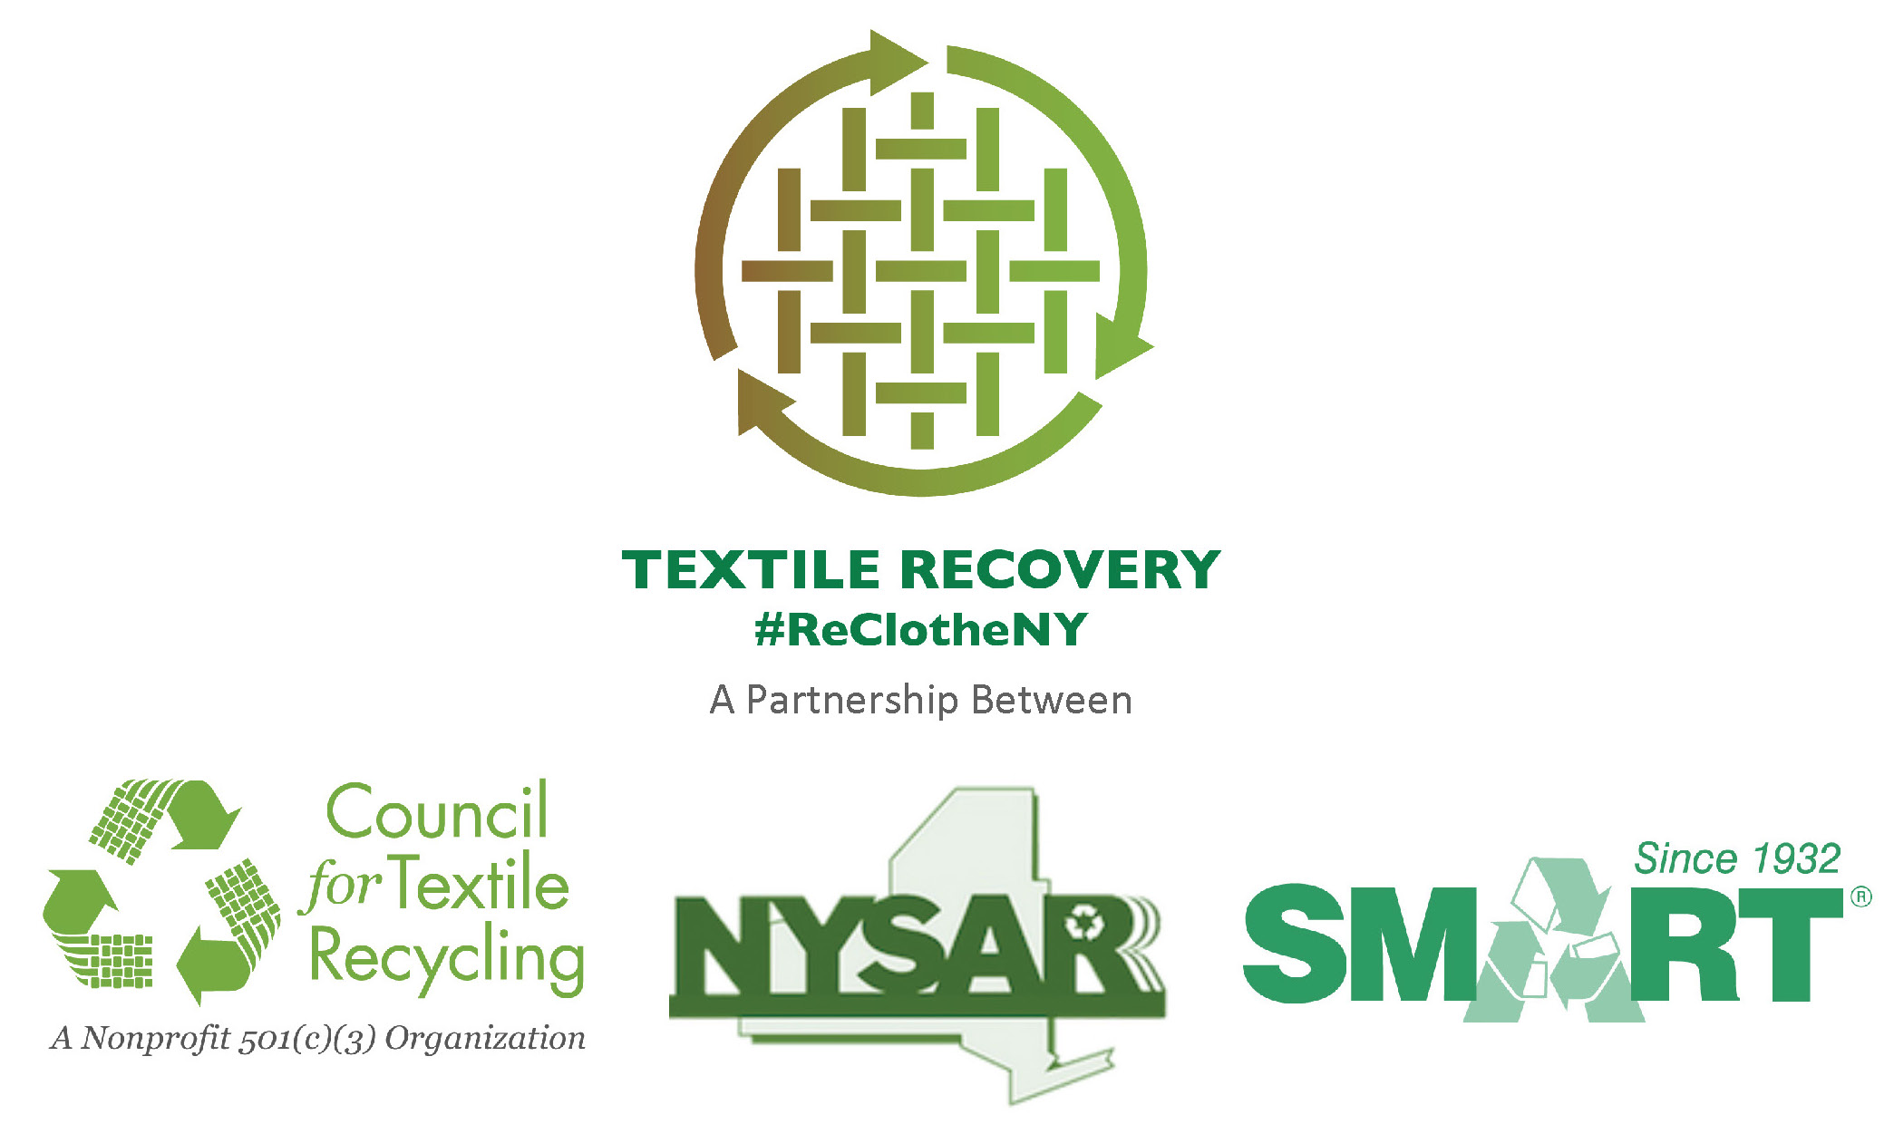
10/21/14

NEWS RELEASE

FOR IMMEDIATE RELEASE

CONTACT: Name
Title
Municipality/Department
XXX-XXX-XXXX (office)
XXX-XXX-XXXX (cell)
EMAIL:

(insert name of municipality) Residents Make Launch of “Re-Clothe NY” Recycling Event a Huge Success

More than XXX Pounds of Clothing, Footwear and Textiles
Diverted from Landfill at Kick-Off Event

New York State residents dispose of some 1.4 billion pounds of textiles annually,
with a market value exceeding $200 million.
Over 9,000 jobs would be created across the state
if those materials were recovered for reuse and recycling.

Town, NY (Month XX, 2014) – Solid Waste officials of insert name of municipality or agency have joined a statewide environmental campaign reminding residents to recycle all unwanted clothing, footwear, and other textiles such as sheets, towels, tablecloths, even underwear and single socks. As part of the statewide campaign, insert name of department or agency hosted a “Re-Clothe NY” recycling event yesterday (Date) where more than _____ pounds of clothing and other cloth products were recycled. Residents are urged to drop off textiles at a charitable organization, or by using clothing collection bins—they should NOT be placed in curbside recycling containers. Residents can find the nearest drop off location by visiting ________________ or www.NYTextiles.org
“In our community, some (insert calculation of 5% of local MSW waste stream) tons of clothes and textiles, with an estimated market value of $ (insert calculation of: $0.15 x .05 x total local MSW tons x 2000) are trashed every year. This is the first step towards recovering that material to create local jobs and reduce the amount of recoverable clothing and other textile products that are trashed annually, “ says Name, Title. “ “We want everyone to stop putting clothing into the trash – even if it’s ripped, missing buttons, has a broken zipper, or is slightly stained -- and start sending all unwanted clothing and other textiles into the reuse/recycling stream; whether by dropping them off at their favorite charitable organization, or by using clothing collection bins—they should NOT be placed in curbside recycling containers. Both non-profit charities and for-profit recyclers often work in conjunction to keep this valuable resource out of the waste stream.”

Every year, New York State residents dispose of some 1.4 billion pounds of textiles, with a market value exceeding $200 million. Over 9,000 jobs would be created across the state if those materials were recovered for reuse and recycling.

The average American puts 70 pounds of clothing, footwear, or textiles into local landfills or waste-to-energy facilities (waste combustors). The New York State Association for Reduction, Reuse and Recycling (NYSAR³), the Secondary Materials and Recycled Textiles Association (SMART) and the Council for Textile Recycling (CTR) want the public to know that 95% of all clothing and textile products can be recycled. In addition to reuse, the repurposing of textile products includes converting them into wiping cloths or remanufacturing them into products such as home insulation, carpet padding, or sound proofing material. “Only 5 percent of all textile materials are ultimately disposed of as trash because they are either wet or are contaminated with oil, paint, or some other hazardous material,” says SMART Executive Director, Jackie King. “As long as the items are clean and dry, even if they are stained or damaged, there is a recycling use for the material.”

According to the United States Environmental Protection Agency, on a national level, more than 13 million tons of solid municipal waste is generated annually that is exclusively clothing and other household textiles; of this amount, 2 million tons, or only about 15.3%, is recycled.¹

“Typically, clothing and textiles are not considered by the general public to be recyclable products like plastic bottles, aluminum cans, and paper. We are very pleased to be a part of the state-wide educational effort to get New York residents to recognize the fact that used clothing is a recyclable,” says CTR President, Eric Stubin . “Not only does this remove these items from the waste stream, the EPA reports recycling used clothing has a major beneficial impact on reducing greenhouse gasses.”

In its 2011 study of Municipal Solid Waste, the U.S. EPA calculated the impact the current level of recycling has on greenhouse gasses (GHG) in the United States. The EPA report indicates that two million tons of textiles are currently recycled annually; this is the equivalent of removing one million cars from America’s highways. This is more than 5-times the GHG reduction impact of recycled yard trimmings (equivalent to 170,000 cars removed); is more than 4-times the GHG reduction impact of current glass recycling (210,000 cars removed); more than plastic recycling GHG reductions (640,000 cars removed); and is nearly equal to the GHG reduction impact of current aluminum recycling (1.3 million cars removed).²

Name of municipality___ will be launching a new ________ program for the collection of clothing, footwear and other cloth (textile) products beginning ________.

For additional information, of the “Re-Clothe NY” program, contact __________ at ________ or by email at _____________________ For general information about the state-wide program visit www.NYTextiles.org

SOURCE:
¹Table 1, Page 7. Municipal Solid Waste Generation, Recycling, and Disposal in the United States: Facts and Figures for 2011.

² Table 5, Page 12. Municipal Solid Waste Generation, Recycling, and Disposal in the United States: Facts and Figures for 2011.

About
The New York State Association Reduction, Reuse and Recycling (NYSAR³) is New York State’s largest recycling association, representing professionals from the public, not-for-profit, and private sectors. Each day, these individuals provide statewide leadership on waste reduction, reuse and recycling issues and advance practices to improve the environment, generate jobs, and create a more sustainable future.

About
Secondary Materials and Recycled Textiles (SMART) is an international nonprofit trade association that strengthens the economic opportunities of its diverse membership by promoting the interdependence of our industry segments and providing a common forum for networking, education and trade. Since 1932, SMART has been at the forefront of recycling. SMART members use and convert recycled and secondary materials from used clothing, commercial laundries and non-woven, off spec material, new mill ends and paper from around the world. SMART member companies create thousands of jobs worldwide. SMART members prove each day that you can make money by being socially responsible.

For additional information on SMART, visit the association’s website at www.SMARTasn.org. The following link will take you directly to informational videos on textile recycling http://www.smartasn.org/about/videos.cfm. To download the iRecycle app visit www.Earth911.com. The app allows users to find clothing and textile recycling drop-off locations in their area.

About
The Council for Textile Recycling is a 501(c)(3) nonprofit, tax exempt organization incorporated in the State of Maryland. The CTR is not involved in the collection of textile waste in any form and is entirely devoted to creating more awareness about keeping post-consumer textile waste out of our solid waste stream. Our non-profit headquarters are located at 3465 Box Hill Corporate Center Drive, Suite H, Abingdon, Maryland 21009. Phone: 443-640-1050.

#####

