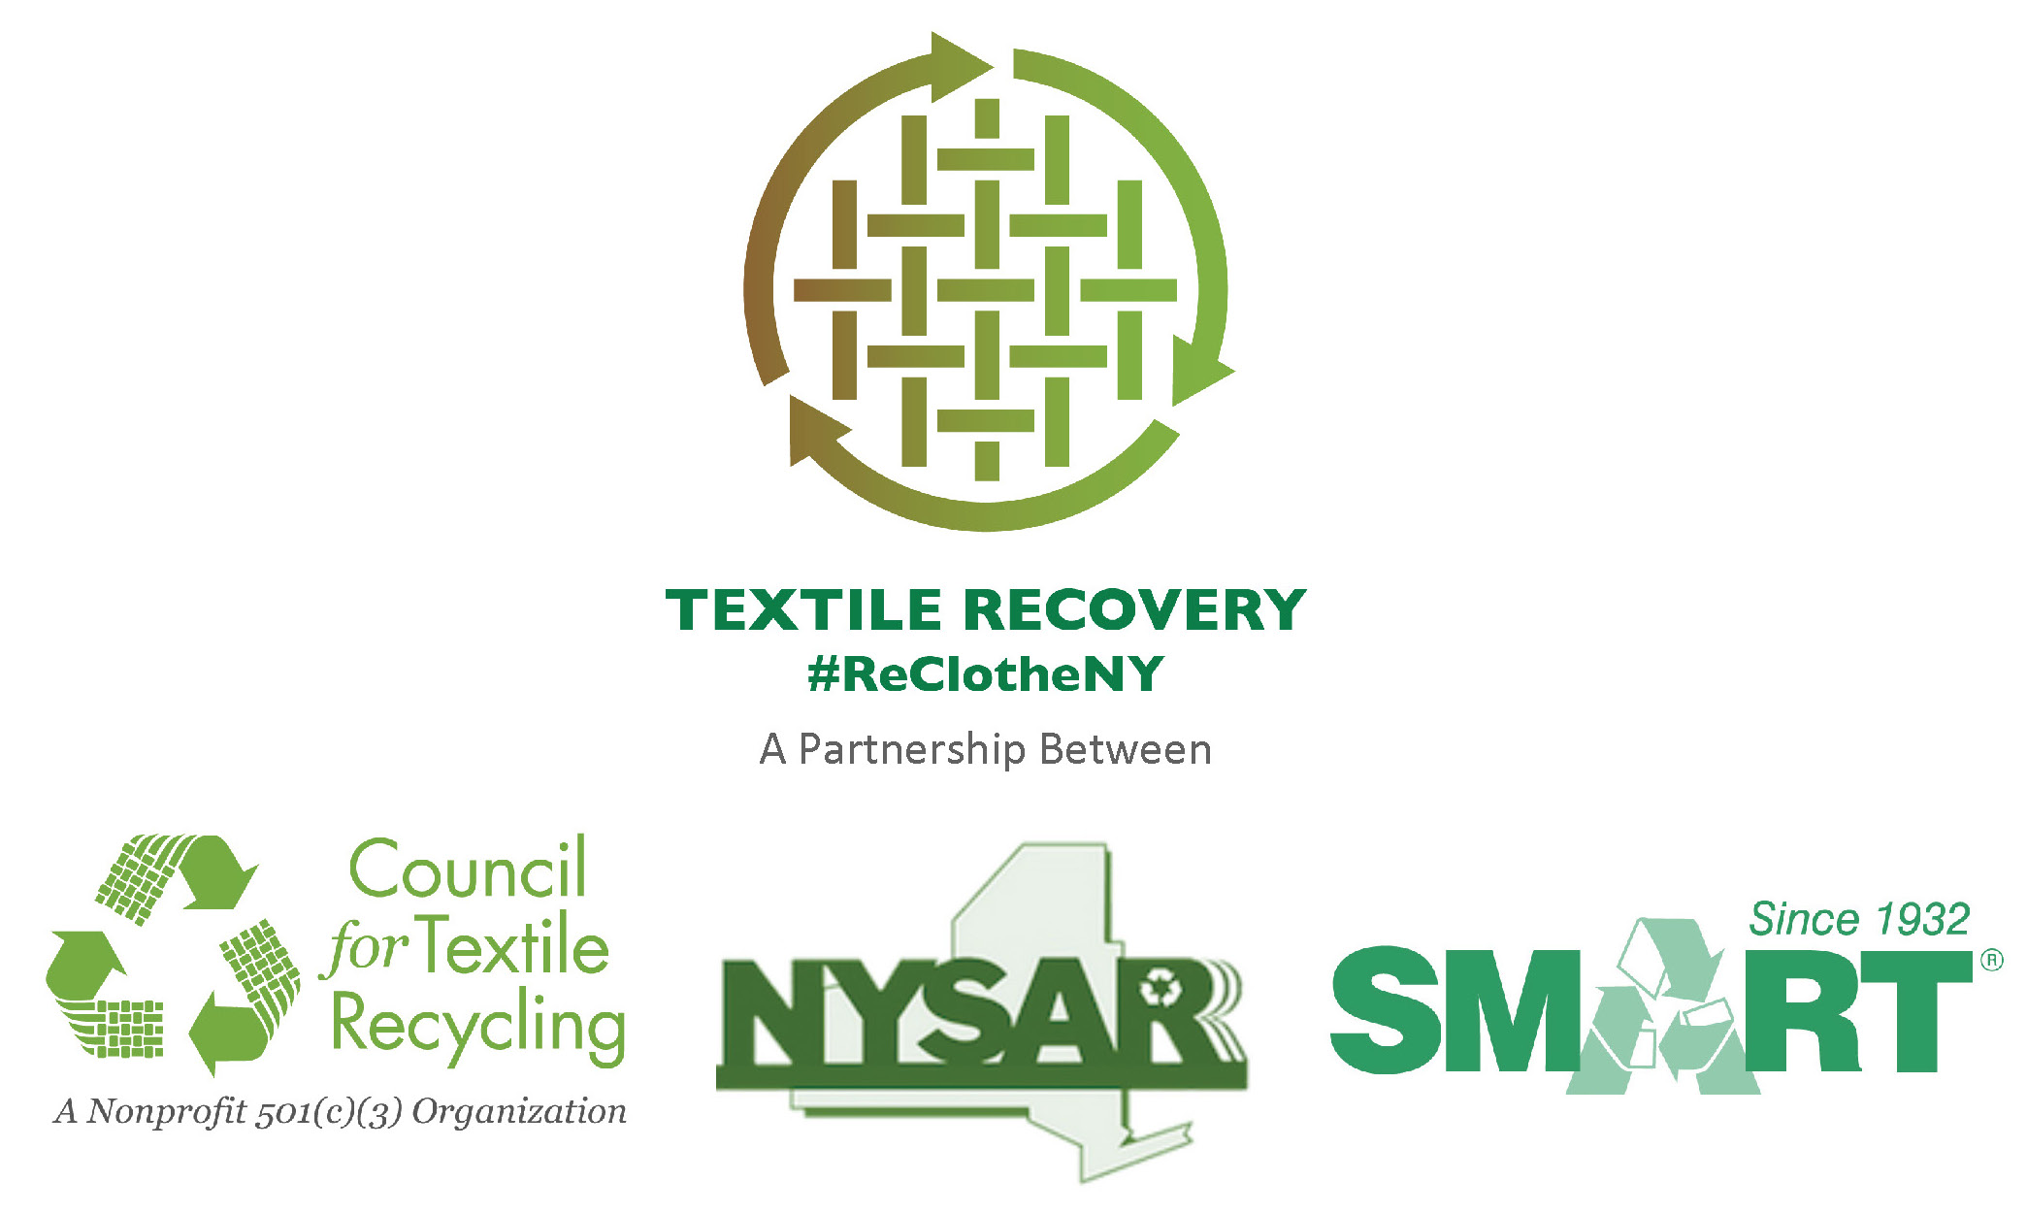

NYSAR3 – Radio PSA Script
Re-Clothe: Recycle, Don’t Throw Away
:30 Seconds

NYSAR3 – Radio PSA Script
“Clothes the Loop: Recycle, Don’t Throw Away :30 Seconds

Studio Host – Live Read | When most people think of recycling, they only think of paper, bottles, and cans. Unfortunately, many people don’t realize they can also recycle clothing and other textiles, even if it is ripped or stained!  Over one billion pounds of clothing and textiles are trashed in New York state annually. The (insert name of local solid waste department or agency) and the New York State Association of Reduction, Reuse, and Recycling urge you to drop off all unwanted clothing at a collection box or to (insert name of local charitable organizations that collect clothing and textiles ).  Visit NYtextiles.org and use the recycling locator tool to find your nearest recycling drop off point.  When it comes to your unwanted clothing, “Re-Clothe NY”… Donate. Recycle. Don’t, Throw Away!

