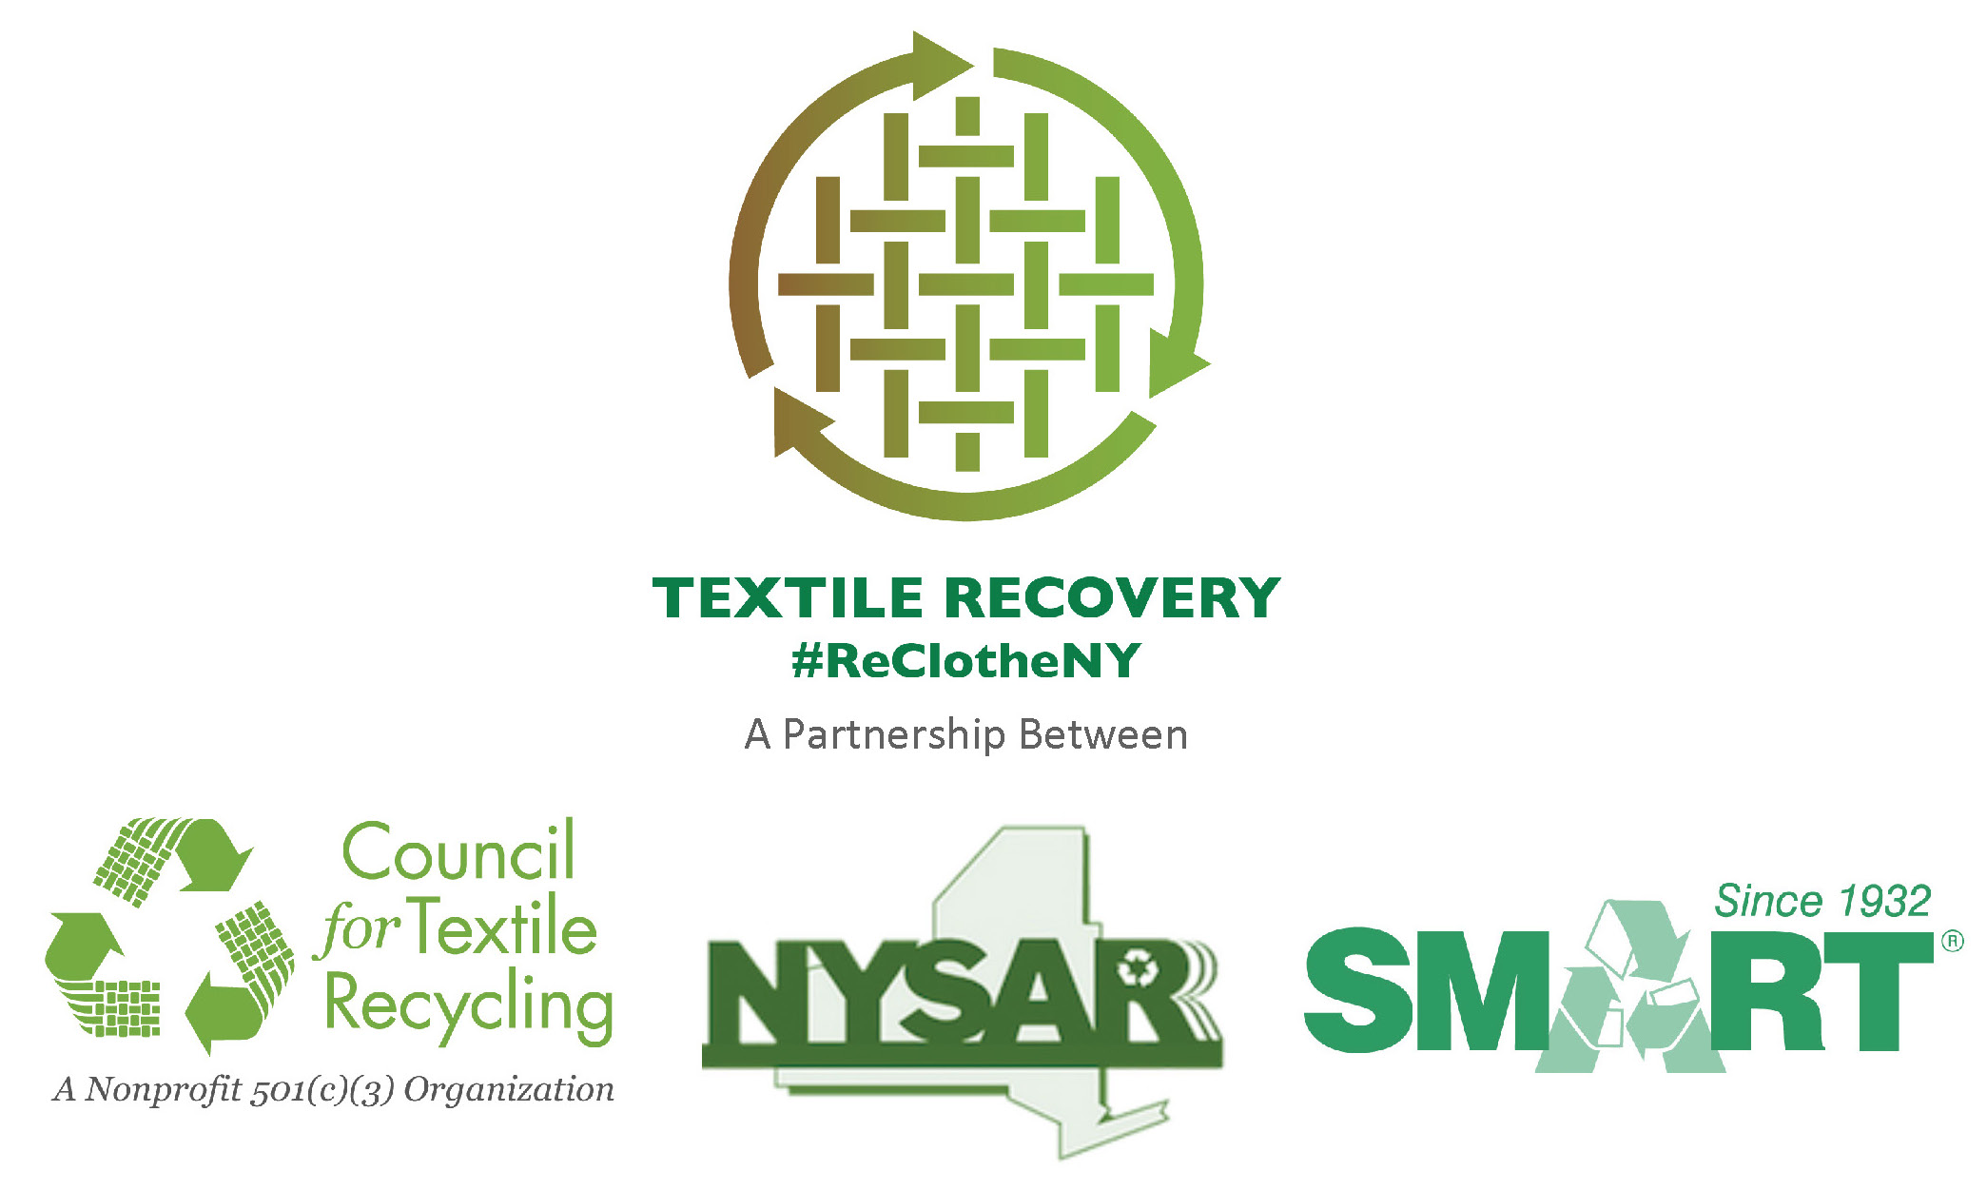
10/21/14

TALKING POINTS FOR MEDIA INTERVIEWS
AND PUBLIC PRESENTATIONS

WHY ARE NYSAR³, SMART, AND CTR CONDUCTING THIS CAMPAIGN?
- NY State residents trash over 1.4 BILLION POUNDS of clothes and textiles annually, with a market value exceeding $200 million, plus another $36 million in costs to dispose of these recoverable materials. In our community, (insert calculation of 5% of total MSW) tons of clothes and textiles are trashed annually.
- Over 9,600 jobs could be created statewide if this material was recovered for reuse and recycling.
- Figures from the EPA’s 2012 report on municipal solid waste show that about 5% of all of the materials going into landfills or waste to energy facilities (waste combustors) is clothing or textile products. Our cities and counties can extend the life of their landfills by diverting used clothing and textiles out of the waste stream and into reuse and recycling programs.

WHAT CAN BE RECYCLED?
- NYSAR³, SMART and the Council for Textile Recycling estimate 95% of all used clothing, footwear and other cloth household products such as sheets, towels, curtains, and pillowcases can be recycled.
Even if items are torn… stained… are missing buttons… have broken zippers, etc., they can still be recycled. As long as the items are dry and odor-free (not stained with solvents such as gasoline) they can be recycled. For a complete list of acceptable materials, please visit www.nytextiles.org
- Of all of the used clothing and household textiles that are currently being recycled, SMART estimates:
  - 40% is re-used for its original purpose (i.e. as an item of clothing).
  - Approximately 30% is cut into industrial wiping and polishing cloths.
  - 25% is shipped to mills that shred the textiles into fiber that is then used to manufacture new products such as home insulation, car soundproofing, carpet padding and stuffing for upholstered furniture and pet bedding.
  - The remaining 5% is thrown away because it is wet (mildewed) or had been stained with a solvent such as gasoline.

WHAT ARE THE ENVIRONMENTAL IMPACTS?
The average American throws away an estimated 70 pounds of unwanted clothing, footwear and other textile products annually.
- 85% of the nation’s used clothing and household textiles that could have been reused/ recycled winds up in landfills; only 15% is being reused or recycled.
- According to the U.S. Environmental Protection Agency, currently, 2.25 million tons of used clothing and household textiles are recycled annually, while more than 12 million tons (12.08 million) are discarded in our nation’s landfills and waste to energy facilities (waste combustors).

- About 24 pounds of CO₂ are reduced for every 100 pounds of textiles that are recycled or reused.
- According to the U.S. EPA, recycling used clothing and household textiles has a significant impact on reducing greenhouse gasses (GHG). Today, we recycle two million tons of clothing/textiles per year across the US. This is the equivalent of removing one million cars from the nation’s roads. This has a greater GHG reduction impact than:
  - the current amount of recycling of yard waste (equals removing 170,000 cars annually )
  - the current amount of recycling of glass (equals removing 210,000 cars annually)
  - the current amount of recycling of plastics (equals removing 640,000 cars annually)
  - and is nearly equal to the GHG reduction impact of the current amount of aluminum recycling (equals removing 1.3 million cars annually).

SOURCE: U.S. Environmental Protection Agency report: Municipal Solid Waste Generation, Recycling, and Disposal in the United States: Facts and Figures for 2012.

U.S. Census Bureau. U.S. Population as of January 1, 2013
(used to calculate pounds per person thrown away annually by dividing EPA waste figure for 2012)

About
The New York State Association Reduction, Reuse and Recycling (NYSAR³) is New York State’s largest recycling association, representing professionals from the public, not-for-profit, and private sectors. Each day, these individuals provide statewide leadership on waste reduction, reuse and recycling issues and advance practices to improve the environment, generate jobs, and create a more sustainable future.

About
Secondary Materials and Recycled Textiles (SMART) is an international nonprofit trade association that strengthens the economic opportunities of its diverse membership by promoting the interdependence of our industry segments and providing a common forum for networking, education and trade. Since 1932, SMART has been at the forefront of recycling. SMART members use and convert recycled and secondary materials from used clothing, commercial laundries and non-woven, off spec material, new mill ends and paper from around the world. SMART member companies create thousands of jobs worldwide. SMART members prove each day that you can make money by being socially responsible.

For additional information on SMART, visit the association’s website at www.SMARTasn.org. The following link will take you directly to informational videos on textile recycling http://www.smartasn.org/about/videos.cfm. To download the iRecycle app visit www.Earth911.com. The app allows users to find clothing and textile recycling drop-off locations in their area.

About
The Council for Textile Recycling is a 501(c)(3) nonprofit, tax exempt organization incorporated in the State of Maryland. The CTR is not involved in the collection of textile waste in any form and is entirely devoted to creating more awareness about keeping post-consumer textile waste out of our solid waste stream. Our non-profit headquarters are located at 3465 Box Hill Corporate Center Drive, Suite H, Abingdon, Maryland 21009. Phone: 443-640-1050.

